 

AI POWERED NUTRITION ANAYSER FOR FITNESS ENTHUSIATS

# A PROJECT REPORT

***Submitted by***

|  |  |
| --- | --- |
| **RITIK MAGOTRA** | **(621319104044)** |
| **KEERTHIVASAN R** | **(621319104304)** |
| **AJITHKUMAR G** | **(621319104301)** |
| **MUKESHKUMAR** | **(621319104035)** |

***in partial fulfillment for the award of the degree of***

**BACHELOR OF TECHNOLOGY**

***in***

# COMPUTER SCIENCE AND ENGINEERING

**KONGUNADU COLLEGE OF ENGINEERING AND TECHNOLOGY (AUTONOMOUS)**

**ANNA UNIVERSITY :: CHENNAI 600 025**

# NOV 2022

**KONGUNADU COLLEGE OF ENGINEERING AND TECHNOLOGY (AUTONOMOUS)**

**ANNA UNIVERSITY :: CHENNAI 600 025**

**BONAFIDE CERTIFICATE**

Certified that this project report “**AI POWERED NUTRITION FOR FITNESS ENTHUSIASTS”** is the bonafide work of “**RITIK MAGOTRA (621319104044), KEERTHIVASAN R (621319104304), AJITHKUMAR G**

**(621319104301), MUKESHKUMAR (621319104035)”** who carried out the project work under my supervision.

## SIGNATURE SIGNATURE

Dr.C.Saravanabhavan, M.Tech., (Ph.D.,) MR.R. PREMKUMAR

**HEAD OF THE DEPARTMENT MENTOR**

Professor, Assistant Professor,

Department of Computer Science and Department of Computer Science and

Engineering, Kongunadu College of Engineering, Kongunadu College of, Engineering and Technology, Engineering and Technology, Thottiam, Trichy-621 215 Thottiam, Trichy-621 215

Submitted for the project viva-voce examination held on

**INTERNAL EXAMINER EXTERNAL EXAMINER**

**ACKNOWLEDGEMENT**

We wish to express our sincere gratitude to our beloved chairman **Dr.PSK.R.PERIASWAMY** for providing the facilitation to make us extensively internationalized to meet global competence with almost perfection.

We would like to express our sincere thanks to our Principal **Dr.R.ASOKAN, M.S., M.Tech., Ph.D.,** for the facilities and the encouragement given to the progression and completion of this project.

We proudly render our immense gratitude to **Dr.C.Saravanabhavan, M.Tech., (Ph.D).,** Professor and Head of the Department, Department of Computer Science and Engineering for his effective leadership, encouragement and supportive guidance to this project.

We proudly render our thanks to our project**, MR.R.PREMKUMAR, M.E., Ph.D.,** Professor, Department of Computer Science and Engineeringfor his valuable ideas, encouragement and supportive guidance throughout this project.

We wish to extend our heartfelt regard and sincere thanks to our project guide **MR.R.PREMKUMAR, M.E., Ph.D.,** Professor, Department of Computer Science and Engineeringfor his motivation, continuous encouragement and expert guidance throughout this project.

We wish to extend our sincere thanks to all faculty members of Information Technology Department for their valuable suggestions, kind cooperation and encouragement on successful completion of this project.

Finally, we profound gratitude to the almighty for his presence and who gave me the bravery, privilege, power and belief to complete this project

# ABSTRACT

Our project aims at detecting and identifying the food item whose details are existing in the designed database and gives us certain details such as the calories and nutrients .The food item consists of, and along with this, our project provides advice on how much amount of calories and nutrients the user must take according to the user's details and his/her required intake for healthy diet and fitness. Nutritional analysis is the process of determining the nutritional content of food. This helps the fitness enthusiast to tract and monitor their intake nutrition and calorie intake.The purpose of nutritional screening is to rapidly identify patients at high nutritional risk. The purpose of nutritional assessment, however, is to define a patient’s nutritional status, to define clinically relevant malnutrition and to monitor changes in nutritional status. Nutritional risk continues to be unrecognized and undertreated in clinical practice. Hospitals need to develop comprehensive strategies for identifying and treating malnutrition at hospital admission and for monitoring the nutritional status of patients during their hospital stay. There are three basic needs for human living: food, home, and clothes. As a result, food plays a critical part in human life. In today's world, every field achieves some level of accomplishment. We should take food as per our body needs. In recent times, many dangerous diseases have taken place in the human body. It is essential to know what we should eat in our diet. This paper explores different methods and datasets for food recognition and nutrition assessment from the images of different foods using artificial intelligence and compares different methods and technologies also. Convolutional Neural Network (CNN) is one of the most successful deep learning algorithms for food recognition. As a finding, several existing models of CNN have been explored.

i

|  |  |  |
| --- | --- | --- |
| **SI.NO** | **TITLE** | **PAGE NO** |
| **1.** | **INTRODUCTION** | 3 |
|  | 1.1 Project Overview | 4 |
|  | 1.2 Purpose | 5 |
| **2.** | **LITERATURE SURVEY** | 6 |
|  | 2.1 Existing problem | 11 |
|  | 2.2 References | 12 |
|  | 2.3 Problem Statement Definition | 13 |
| **3.** | **IDEATION & PROPOSED SOLUTION** | 14 |
|  | 3.1 Empathy Map Canvas | 14 |
|  | 3.2 Ideation & Brainstorming | 15 |
|  | 3.3 Proposed Solution | 16 |
|  | 3.4 Problem Solution fit | 17 |
| **4.** | **REQUIREMENT ANALYSIS** | 18 |
|  | 4.1 Functional requirement | 18 |
|  | 4.2 Non-Functional requirements | 19 |
| **5.** | **PROJECT DESIGN** | 20 |
|  | 5.1 Data Flow Diagrams | 20 |
|  | 5.2 Solution & Technical Architecture | 24 |
|  | 5.3 User Stories | 25 |
| **6.** | **PROJECT PLANNING & SCHEDULING** | 26 |
|  | 6.1 Sprint Planning & Estimation | 26 |
|  | 6.2 Sprint Delivery Schedule | 27 |
|  | 6.3 Reports from JIRA | 31 |

|  |  |  |
| --- | --- | --- |
| **7.** | **CODING & SOLUTIONING** | 32 |
|  | 7.1 Feature 1 | 32 |
|  | 7.2 Feature 2 | 33 |
|  | 7.3 Database Schema | 33 |
| **8.** | **TESTING** | 42 |
|  | 8.1 Test Cases | 42 |
|  | 8.2 User Acceptance Testing | 43 |
| **9.** | **RESULTS** | 44 |
|  | 9.1 Performance Metrics | 44 |
| **10.** | **ADVANTAGES & DISADVANTAGES** | 48 |
| **11.** | **CONCLUSION** | 49 |
| **12.** | FUTURE SCOPE | 50 |
| **13.** | APPENDIX | 51 |
|  | Source Code |  |
|  | GitHub & Project Demo Link |  |

## CHAPTER 1 INTRODUCTION

AI (artificial intelligence) within the health care sector denotes the application of advanced software and complex algorithms to imitate human perception in analyzing intricate medical data. AI technology differs from traditional technologies linked to the health care industry in the potential to get data, analyze it, and outline a detailed conclusion to a respective user. [Machine](https://peachyessay.com/sample-essay/machine-learning-in-investment-funds-industry/) [learning](https://peachyessay.com/sample-essay/machine-learning-in-investment-funds-industry/) algorithms empower these capabilities in AI technology. The algorithms in AI can detect behavioral patterns and form its logic. Experts regularly test AI algorithms to lower the error margin. Here, there are two differences between the [behavior of humans](https://peachyessay.com/sample-essay/genetics-versus-upbringing/) and AI algorithms. First, algorithms are accurate. Besides, if one sets a purpose, the algorithm does not change itself and only recognize what has been instructed overtly. Second, algorithms denote black boxes. The second difference implies that, while algorithms can estimate correct goals, they do not test the reasons or causes for that outcome. AI thus represents the computer algorithms potential to reckon inferences without direct human contribution.

Artificial intelligence is swiftly progressing to [transform the health care](https://peachyessay.com/sample-essay/transformation-of-va-health-care-system/) industry. Propelled by [big data](https://peachyessay.com/sample-essay/information-security-in-big-data-data-integrity/) as well potent systems of machine learning, pioneers create tools to enhance the clinical care process, to improve the deficiency, and enhance medical research. These tools depend on programs and algorithms [developed from health care](https://peachyessay.com/sample-essay/applying-ethical-principles/) information that can suggest recommendations or predictions. Experts consider the algorithms as mostly hard to explicitly state or understand their reasoning .Because of this, some professionals consider these algorithms .The research focuses on the perception of [artificial intelligence](https://peachyessay.com/sample-essay/artificial-intelligence-friend-or-foe/), which entails the likely applications. The paper also describes the legal implications of AI in medicine including regulation, privacy, tort, and intellectual [property law.](https://peachyessay.com/sample-essay/property-law-statutory-power-of-sale-by-a-mortgagee/) AI in the [health care](https://peachyessay.com/sample-essay/universal-healthcare-us/) industry seems beneficial, it includes some business, ethical, and legal concerns worth addressing to improve the primacy of this technology. AI has the potential to be very effective. It can bring innovative ways of teaching students with the help of which students will be able to learn the concepts better. Artificial intelligence is the future of innovative technology as we can use it in many fields.

## 1.1 PROJECT OVERVIEW

Nutritional Sector: Artificial Intelligence finds diverse applications in the [nutritional](https://www.simplilearn.com/ai-in-healthcare-article) [sector.](https://www.simplilearn.com/ai-in-healthcare-article) AI applications are used in analysis to build sophisticated machines that can detect diseases and identify cancer cells. Artificial Intelligence can help analyze chronic conditions with lab and other medical data to ensure early diagnosis. AI uses the combination of historical data and powered intelligence for the discovery of new diatery. Food analyser: AI has been successfully deployed for applications such as sorting fresh produce, managing supply chain, food safety compliance monitoring, effective cleaning in place systems, anticipating consumer preference and new product development with greater efficiency and savings on time and resources.Image Recognition: Our favorite devices like our phones, laptops, and PCs use facial recognition techniques by using face filters to detect and identify in order to provide secure access. Apart from personal usage, facial recognition is a widely used Artificial Intelligence application even in high security-related areas in several industries.Diet and Fitness: Diet significantly improve packaging, increasing shelf life, a combination of the menu by using AI algorithms, and food safety by making a more transparent supply chain management system. With the help of AI and ML, the future of food industries is completely based on smart farming, robotic farming, and drones.cleaning in place systems, anticipating consumer preference and new product development with greater efficiency and savings on time and resources.Recommendation System: Various platforms that we use in our daily lives like e-commerce, entertainment websites, social media, video sharing platforms, like youtube, etc., all use the recommendation system to get user data and provide customized recommendations to users to increase engagement. This is a very widely used Artificial Intelligence application in almost all industries. Image Recognition: Our favorite devices like our phones, laptops, and PCs use facial recognition techniques by using face filters to detect and identify in order to provide secure access. Apart from personal usage, facial recognition is a widely used Artificial Intelligence application even in high security- related areas in several industries.

## PURPOSE

* + - Food is essential for human life and has been the concern of many healthcare conventions. Nowadays new dietary assessment and nutrition analysis tools enable more opportunities to help people understand their daily eating habits, exploring nutrition patterns and maintain a healthy diet. Nutritional analysis is the process of determining the nutritional content of food. It is a vital part of analytical chemistry that provides information about the chemical composition, processing, quality control and contamination of food.
    - The main aim of the project is to building a model which is used for classifying the fruit depends on the different characteristics like colour, shape, texture etc. Here the user can capture the images of different fruits and then the image will be sent the trained model. The model analyses the image and detect the nutrition based on the fruits like (Sugar, Fibre, Protein, Calories, etc.).
    - The purpose of nutritional assessment, on the other hand, is to define a patient’s nutritional status, to identify clinically relevant malnutrition and to monitor changes in the patient’s nutritional status. It records anthropometric, dietary and bio-chemical measurements, clinical history, findings at physical examination and other parameters. The Subjective Global Assessment and the Mini Nutritional Assessment are nutritional assessment tools. An advantage of nutritional screening tools over nutritional assessment tools is that they require less training to administer them. The choice of tool depends on the type of hospital, the population to be screened or assessed and the resources available.
    - Finally, the accuracy of the conversion of nutrient totals from nutrition dietary records depends on the accuracy and availability of the food ingredient database for conversion to calories and nutrients. In summary, both types of errors reduce the judgement of the relationship between diet and health, as well as the accuracy of the statistical analysis. However, while there may be some slight deviations in the database of the relationships tested when the results of significant analyses are properly evaluated, valid conclusions can be drawn.

## CHAPTER 2 LITERATURE SURVEY

1. **TITLE: A SURVEY OF NUTRITION AI RECOMMENDATION SYSTEM AUTHOR: Thomas Theodoridis,Vassilios Solachidis, Lazaros**

## YEAR OF PUBLICATION: 2020

Nutrition informatics has become a novel approach for registered dietitians to practice in this field and make a profit for health care. Recommendation systems considered as an effective technology into aid users to adjust their eating behavior and achieve the goal of healthier food and diet. The purpose of this study is to review nutrition recommendation systems (NRS) and their characteristics for the first time. The systematic review was conducted using a comprehensive selection of scientific databases as reference sources, allowing access to diverse publications in the field. The process of articles selection was based on the PRISMA strategy. We identified keywords from our initial research, database and expert’s opinion. Databases of PubMed, Web of Sciences, Scopus, Embase, and IEEE were searched. After evaluating, they obtained records from databases by two independent reviewers and inclusion and exclusion criteria were applied to each retrieved work to select those of interest. Our critical view pointed out that we have a more inclusive and general definition abouthate speech than other perspectives found in the literature. This is the case, because we proposethat subtle forms of discrimination on the internet and online social networks should also be spotted.

## DISADVANTAGES:

* + Some limitations of nutrition screening include not validating tools for specific patient populations for high level.
  + Inacurrate information, changes to a patient &conditions during hospitalization, and the use of invalidated laboratory values.

## TITLE: NUTRITIONAL ASSISTANCE DURING EXERCISE OR PHYSICAL

**AUTHOR: Jinti Roy and Chandrama Baruah YEAR OF PUBLICATION: 2020**

Artificial Intelligence (AI) is a disruptive technology that is utilized to understand more about personalized diet in nutrition and wellness. Experts have modeled linear and nonlinear relationships between various nutritional factors affecting us. This model is used by food companies and personalized food product services to make better predictions and dietary choices. It is done by analyzing the individuals’ genetic details by deep learning to make accurate predictions and appropriate dietary guidelines. AI could be very useful in their mining. This chapter provides a discussion about the importance of nutrition and fitness for health and well-being; what is precision medicine, AI, precision nutrition, and precision fitness; how AI could help with precision nutrition and precision fitness; decision- making algorithm for nutritional meal planning/dietary menu planning; AI-based diet and supplements; AI used in genetic tests for precision nutrition and fitness; AI approach to nutritional meal planning for AI-based nutrition and fitness support systems and apps and some challenges and future perspectives, tweets data are collected from storm front and crowd fewer dataset. The collected data are processed using an NLP approach. Data characters, hash tags, user information and other unwanted details are removed using the NLP tokenization process. The system analyzesTweets in terms of sentence and words, and then it derives NLP features, which are called semantic, sentiment, unigram and pattern features. Nutrient consumption is to switch fluid losses and the supply carbohydrate for the up keeper of blood glucose levels

## DISADVANTANGES:

* + The accuracy of diet analysis is limited by poor record keeping and inaccurate reporting of food intake.

## TITLE: PERSONALISED NUTRITION USING AI

**AUTHOR: Daniela Braconi , Vittoria Cicaloni , Ottavia Spiga YEAR OF PUBLICATION: 2020**

To understand the underlying health dynamics while considering inter-individual variability and implementing personalized nutrition-driven interventions, efforts should focus on devising predictive methods that timely monitor the individual's health responses to food. A systems science perspective can help physicians tailor targeted treatment, comprehend the variability in response to treatments and design personalized nutrition approaches. Personalized nutrition approaches have the potential to spearhead the creation of information- processing representations of digestion, absorption, and metabolism. These provide linkages between molecular events and health outcomes through: integration of data at all salient scales; outcomes through advanced machine learning (ML) models; generation of non- intuitive hypotheses; and experimental validation using preclinical and clinical trials with standardized nutritional interventions. With the advent of big-data era, data specific to consumption of standardized meal, functional food, and beverage sales reports can be extracted. Health informatics enabled initiatives can be applied to conduct data mining and extraction from the electronic health records (EHRs) and insurance claims database. The EHR data can be combined with knowledge derived from nutritional and data sciences to build computational models and synthetic patient cohorts. These synthetic patients can be used as avatars that reflect inter-individual variation to preform predictive analysis and evaluate the system-level responses to the personalized food recommendations. These predictive insights can be utilized in order to elucidate the complex regulatory mechanisms of nutritional interventions at the interface of immunity, metabolism, and gut microbiome.

## DISADVANTAGES:

* Some limitations of nutrition screening include not validating tools for specific patient populations.
* Inaccurate information changes to a patient & condition during hospitalization, and the use of invalidated.

## TITLE: PROSPECTS AND PITFALLS OF MACHINE LEARNING IN NUTRITIONAL EPIDEMIOLOGY

**AUTHOR: Stefania Russo and Stefano Bonassi**

## YEAR OF PUBLICATION: 2020

Nutritional epidemiology employs observational data to discover associations between diet and disease risk. However, existing analytic methods of dietary data are often sub-optimal, with limited incorporation and analysis of the correlations between the studied variables and nonlinear behaviours in the data. Machine learning (ML) is an area of artificial intelligence that has the potential to improve modelling of nonlinear associations and confounding which are found in nutritional data. These opportunities notwithstanding, the applications of ML in nutritional epidemiology must be approached cautiously to safeguard the scientific quality of the results and provide accurate interpretations. Given the complex scenario around ML, judicious application of such tools is necessary to offer nutritional epidemiology a novel analytical resource for dietary measurement and assessment and a tool to model the complexity of dietary intake and its relation to health. This work describes the applications of ML in nutritional epidemiology and provides guidelines to avoid common pitfalls encountered in applying predictive statistical models to nutritional data. Furthermore, it helps unfamiliar readers better assess the significance of their results and provides new possible future directions in the field of ML in nutritional epidemiology.

## DISADVANTAGES:

* + Not only could the data be unintentionally flawed, there is also the risk that it could be intentionally manipulated.
  + Either the data or the neural networks that “teach” the machine learning algorithms.
  + Be programmed to introduce bias or lead clinicians to false conclusion.

## TITLE: NUTRITION SYSTEMS FOR CHILDREN

**AUTHOR: Ahmed Raza and Nita dalmiya YEAR OF PUBLICATION: 2020**

Children are constantly exposed to unhealthy food and brand marketing on digital media. Evidence confirms that unhealthy food/brand marketing adversely affects children’s diet quality and diet-related health. While a growing number of countries, including Canada, aim to regulate unhealthy food/brand marketing to children on digital media, the volume, velocity, and variety of digital media preclude monitoring methods based on human labours. To fill this gap, we are developing an artificial intelligence system that automatically and continuously monitors marketing instances on various types of digital media including websites, YouTube, and mobile apps including social media. Our technology brings together various data science, machine learning, and software engineering methods to improve child health by assisting policy makers to monitor digital food/brand marketing. We have used valuable app analytics data and insights from our 45,000 users to build scalable, predictive models that were validated for specific use cases. Using the Random Forest model with heterogeneous data allowed us to predict user churn with a 93% accuracy. Predicting user lifetimes on the mobile app for preliminary insights gave us an RMSE of 25.09 days and an R2 value of 0.91, reflecting closely correlated predictions. These predictive algorithms allow us to incentivize users with optimized offers and omni- channel nudges, to increase engagement with content as well as other targeted online and offline behaviors. The algorithms also optimize the effectiveness of our intervention by augmenting personalized experiences and directing limited health resources toward populations that are most resistant to digital first interventions. These and similar AI powered algorithms will allow us to lengthen and deepen the lifetime relationship with our health consumers, making more of them effective, proactive participants in improving children's health, nutrition and early cognitive development.

## DISADVANTAGES:

* + Children and adolescents face multiple burdens of malnutrition nutrition systems are critical for improving diets of children and adolescents.

## EXISTING PROBLEM

Expert system for human nutrition analysis is an expert system for diagnosing, controlling, and monitoring human nutrition. The system assesses the physical characteristics of the user to determine their nutritional status and makes recommendations for reaching nutritional requirements and a balanced diet, as a consequence generating a knowledge database with the nutritional status and dietary habits for the user. The system generates challenges, alerts, and constantly motivates the user to use the application and improve their nutritional habits. The expert system is implemented using the Expert System and running as a Web Service on a Window Web Server. The system calculates the BMI, Body Mass Index, the ideal weight and physical contexture, frame size and uses dietary information from. This is our base for nutritional diagnosis on the proposed system. This system will be developed for all users as a tool to improve their eating habits and nutritional wellbeing. The goal is to incorporate the use of this application into their daily lives and help them acquire and maintain healthier eating habits. An expert system or electronic diagnose system is a software hardware system that attempts to reproduce the performance of one or more human experts, most commonly in a specific problem domain, and is a traditional application and/or subfield of artificial intelligence. Such that the computer repository of this expert knowledge in some way, reaching the same conclusion as the expect himself and efficiently replacing him, an expert system or knowledge based system results. It is a complex software (program), designed to imitate the thought processes and decision making patterns of human experts in a given field. The expert system is an off-spring of artificial intelligence (AI) and it is developed using the programming techniques of AI.

## DISADVANTAGES:

* + - Details can be extracted
    - Nutrition can impulse diagnosis

## REFERENCE

1. Jeukendrup A.E., Killer S.C. The myths surrounding pre-exercise carbohydrate feeding. Ann. Nutr. Metab. 2010;57(Suppl. 2):18–25. doi: 10.1159/000322698.
2. Coyle E.F., Coggan A.R., Hemmert M.K., Lowe R.C., Walters T.J. Substrate usage during prolonged exercise following a preexercise meal. J. Appl. Physiol. 1985;59:429– 433.
3. Ahlborg G., Felig P. Influence of glucose ingestion on fuel-hormone response during prolonged exercise. J. Appl. Physiol. 1976;41:1–6.
4. Marmy-Conus N., Fabris S. Preexercise glucose ingestion and glucose kinetics during exercise. J. Appl. Physiol. 1996;81:853–857.
5. DeFronzo R.A., Ferrannini E., Hendler R., Felig P., Wahren J. Regulation of splanchnic and peripheral glucose uptake by insulin and hyperglycemia in man. Diabetes. 1983;32:35– 45. doi: 10.2337/diab.32.1.35.
6. Costill D.L., Coyle E., Dalsky G., Evans W., Fink W., Hoopes D. Effects of elevated plasma FFA and insulin on muscle glycogen usage during exercise. J. Appl. Physiol. 1977;43:695–699.
7. Sparks M.J., Selig S.S., Febbraio M.A. Pre-exercise carbohydrate ingestion: Effect of the glycemic index on endurance exercise performance. *Med. Sci. Sports Exerc.* 1998;30:844– 849. doi: 10.1097/00005768-199806000-00011.
8. M. C. Carter, V. Burley, C. Nykjaer, and J. Cade, “‘my meal mate’(mmm): validation of the diet measures captured on a smartphone application to facilitate weight loss,” *British Journal of Nutrition*, vol. 109, no. 3, pp. 539–546, 2021.

9.[C. K. Martin, J. B. Correa, H. Han, H. R. Allen, J. C. Rood, C. M. Champagne, B. K. Gunturk, and G. A. Bray, “Validity of the remote food photography method (rfpm) for estimating energy and nutrient intake in near real-time,” *Obesity*, vol. 20, no. 4, pp. 891–899,2020

10.Z.Waseem and D. Hovy, ‘‘Hateful symbols or hateful people? Predictive features for hate for nutrition detection on Twitter,’’ Jun. 2016, pp. 88–93.

## PROBLEM STATEMENT DEFINITION

* Our project aims at detecting and identifying the food item whose details are existing in the designed database and gives us certain details such as the calories and nutrients .
* The food item consists of, and along with this, our project provides advice on how much amount of calories and nutrients the user must take according to the user's details and his/her required intake for healthy diet and fitness.
* Nutritional analysis is the process of determining the nutritional content of food.
* This helps the fitness enthusiast to tract and monitor their intake nutrition and calorie intake.
* Food is essential for human life and has been the concern of many healthcare conventions.
* Nowadays new dietary assessment and nutrition analysis tools enable more opportunities to help people understand their daily eating habits, exploring nutrition patterns and maintain a healthy diet.
* Nutritional analysis is the process of determining the nutritional content of food.
* It is a vital part of analytical chemistry that provides information about the chemical composition, processing, quality control and contamination of food.

## CHAPTER 3

**IDEATION &PROPOSED SOLUTIONS 3.1.EMPATHY MAP CANVAS**

An empathy map canvas is a more in-depth version of the original empathy map, which helps identify and describe the user’s needs and pain points. And this is valuable information for improving the user experience. Good canvases rely on insights from actual users, which help provide an accurate picture of how they feel about their experience with the product. This provides insight into which features are accessed the most often and how they are used. And this knowledge empowers teams to make the improvements that most benefit the user and increase the product’s value.

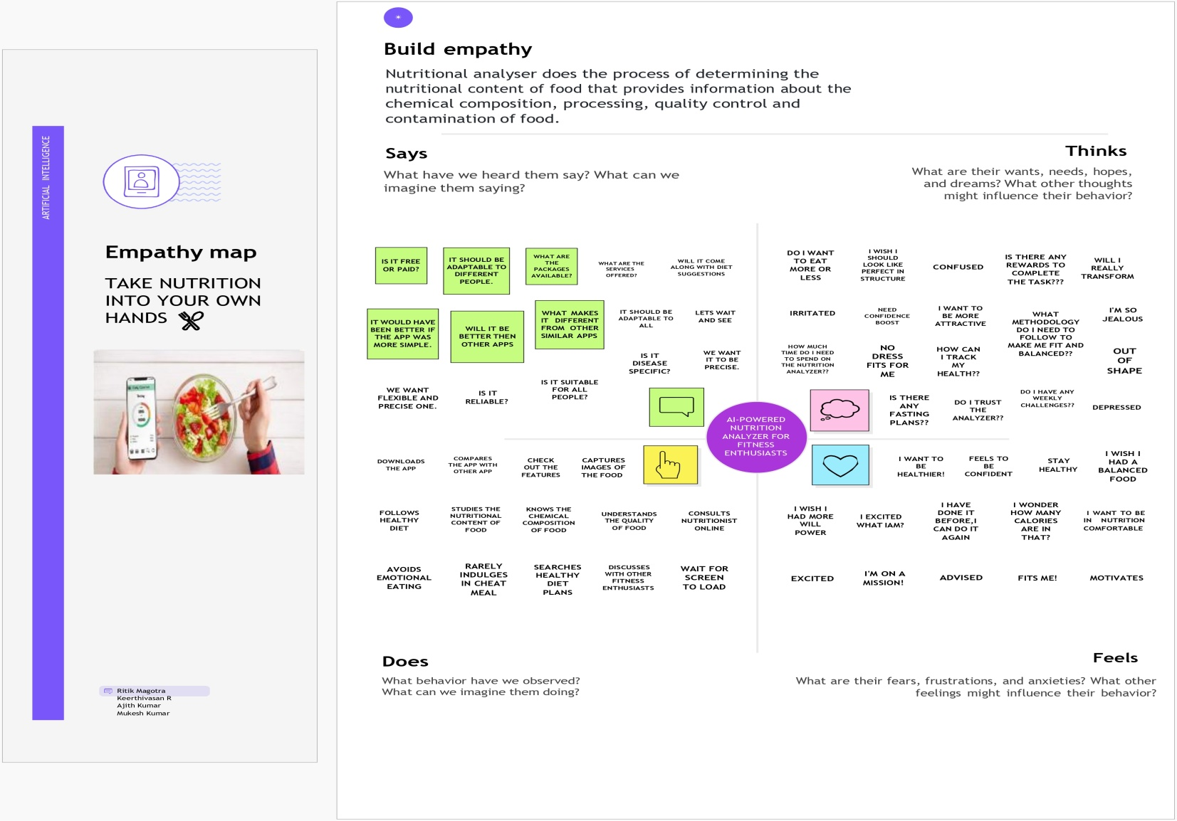

## FIGURE 3.1.1

* 1. **IDEATION AND BRAINSTORMING**

Ideation is the process where you generate ideas and solutions through sessions such as Sketching, Prototyping, Brainstorming, Brainwriting, Worst Possible Idea, and a wealth of other ideation techniques. Ideation is also the third stage in the Design Thinking process. Ideation is the creative process of generating, developing, and communicating ideas. It’s important to note that these ideas don’t have to be completely new. You can ideate to solve specific problems, look into new ways of implementing a solution, or even collect feedback and evaluate ideas. As you can see, ideation is not just a one-time idea generation or a brainstorming session. In fact, we can divide ideation in these three stages: generation, selection, and development. To paint a clearer picture, we’ve illustrated below the ideation process. In this diagram represented as the four types of ideas in nutritional dietary assessment.

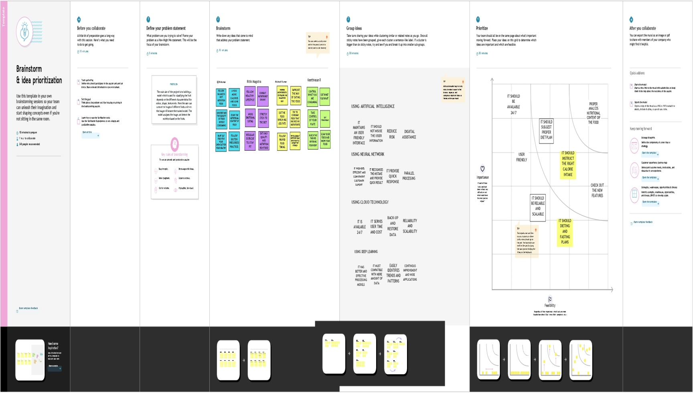

## FIGURE 3.2.1

* 1. **PROPOSED SOLUTION**

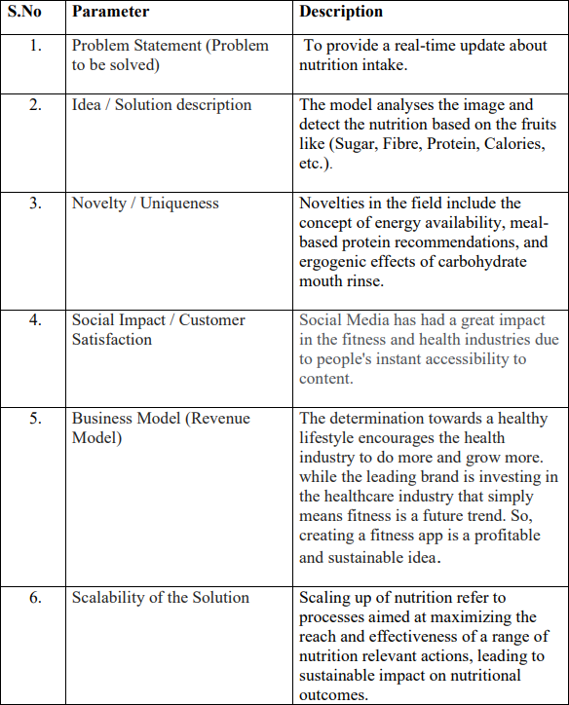

## FIGURE 3.3.1

* 1. **PROBLEM SOLUTION FIT**

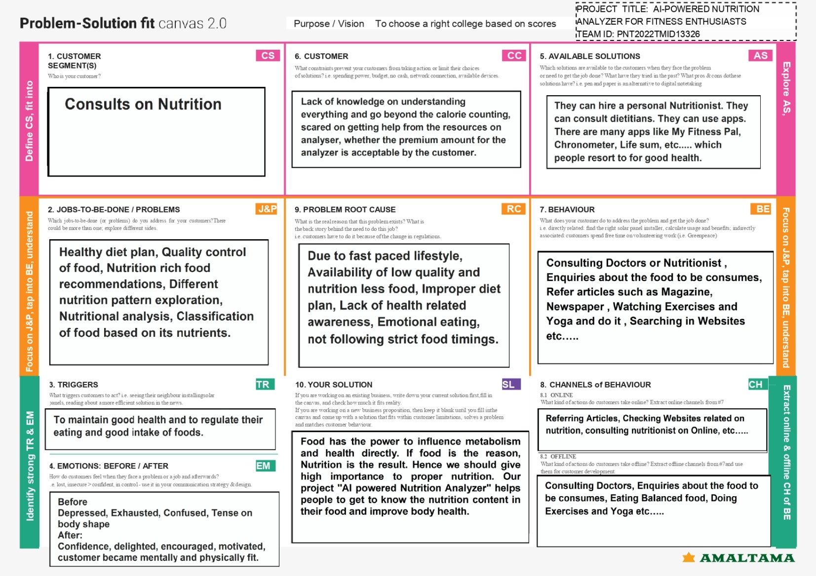

## FIGURE 3.4.1

**CHAPTER 4 REQUIREMENT ANALYSIS**

## FUNCTIONAL REQUIREMENTS

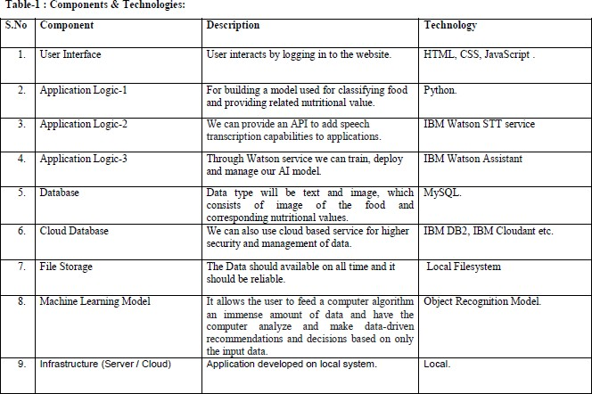

**FIGURE 4.1.1**

## NON-FUNCTIONAL REQUIREMENTS

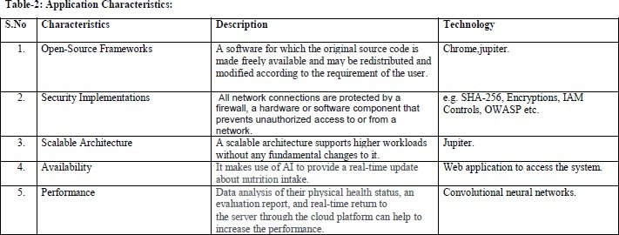

**FIGURE 4.2.1**

## CHAPTER 5 PROJECT DESIGN

**5.1.DATA FLOW DIAGRAMS**

A two-dimensional diagram explains how data is processed and transferred in a system.The graphical depiction identifies each source of data and how it interacts with other data sources to reach a common output. Individuals seeking to draft a data flow diagram must identify external inputs and outputs, determine how the inputs and outputs relate to each other,and explain with graphics how these connections relate and what they result in. This type of diagram helps business development and design teams visualize how data is processed and identify or improve certain aspects.

|  |  |
| --- | --- |
| **Symbol** | **Description** |
| http://cpanel.stpaulsscience.org/gceict/specifications/ocr/unit3/sdlc/dfd/entity.jpg | An **entity**. A source of data or a destination for data. |
| http://cpanel.stpaulsscience.org/gceict/specifications/ocr/unit3/sdlc/dfd/process.jpg | A **process** or task that is performed by the system. |
| http://cpanel.stpaulsscience.org/gceict/specifications/ocr/unit3/sdlc/dfd/store.jpg | A **data store**, a place where data is held between processes. |
| http://cpanel.stpaulsscience.org/gceict/specifications/ocr/unit3/sdlc/dfd/flow.jpg | A **data flow**. |

## FIGURE 5.1.1

**LEVEL 0**

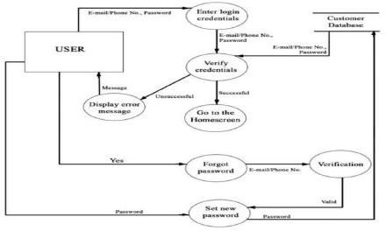

## FIGURE 5.1.2

**LEVEL 1**

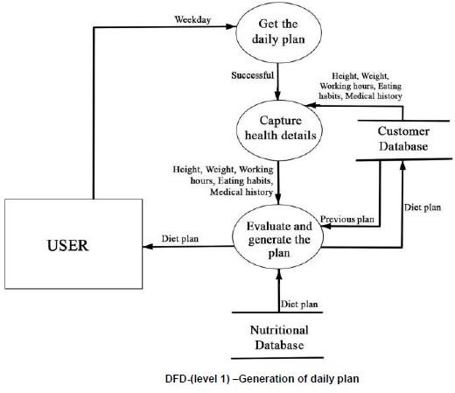

## FIGURE 5.1.3

**LEVEL 2**

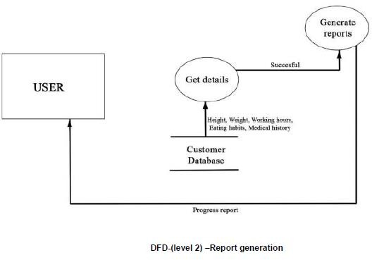

## FIGURE 5.1.4

* 1. **SOLUTION AND TECHNICAL ARCHITECTURE**

Solution architecture helps bring to life how different aspects of business, information, and technology come together in a particular solution. Therefore, a solution architecture diagram should visualize above three critical elements in a way that is useful for both business stakeholders and developers. Based on the complexity of the deployment, a solution architecture diagram may actually be a set of diagrams documenting various levels of the architecture. The diagram relates the information that you gather on the environment to both physical and logical choices for your architecture in an easily understood manner.

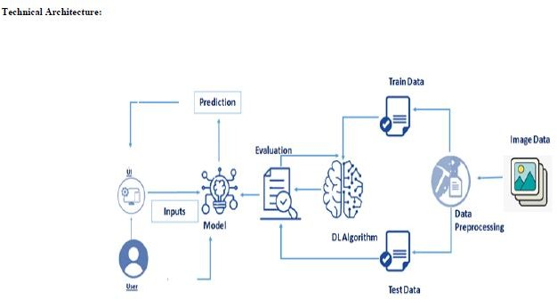

## FIGURE 5.2.1

* 1. **USER STORIES**

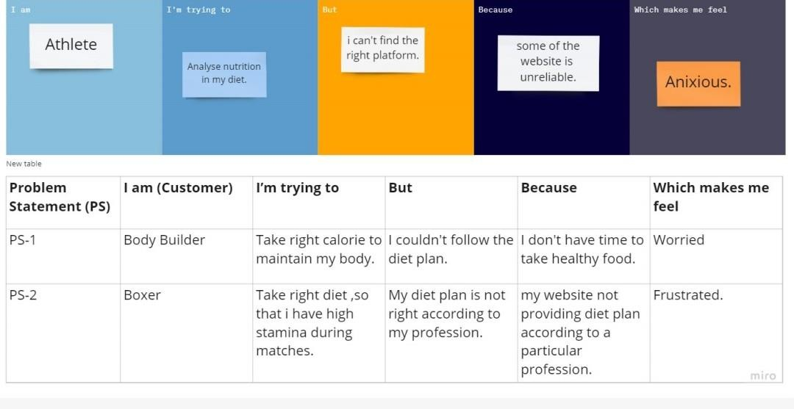

## FIGURE 5.3.1

**CHAPTER 6**

## PROJECT PLANNING AND SCHEDULING

* 1. **SPRINT PLANNING &ESTIMATION**

Sprint planning is an event in scrum that kicks off the sprint. The purpose of sprint planning is to define what can be delivered in the sprint and how that work will be achieved. Sprint planning is done in collaboration with the whole scrum team. Planning One focuses on selection of ready items from those offered by the Product Owner, wrapping up lingering questions, and definition of the Sprint Goal. Sprint Planning Two focuses on creating a plan of work to get to 'done' for each item. The items and plan of action or tasks comprise the Sprint Backlog.

* + - Examine team availability.
    - Establish velocity for your team.
    - Plan your sprint planning meeting.
    - Start with the big picture.
    - Present new updates, feedback, and issue.
    - Confirm team velocity and capacity.
    - Go over backlog items.
    - Determine task ownership.
  1. **SPRINT DELIVERY SCHEDULE**

# Project Planning Phase

|  |  |
| --- | --- |
| Date | 16 October 2022 |
| Team ID | PNT2022TMID13326 |
| Project Name | AI-Powered Nutrition Analyzer For Fitness Enthusiasts |
| Maximum Marks | 8 Marks |

## Project Planning Template (Product Backlog, Sprint Planning, Stories, Story points)

|  |  |  |  |  |  |  |
| --- | --- | --- | --- | --- | --- | --- |
| **Sprint** | **Functional**  **Requirement (Epic)** | **User**  **Story Number** | **User Story / Task** | **Story Points** | **Priority** | **Team Members** |
| Sprint-1 | Data Collection | USN-1 | Dataset - Collecting images of food items apples , banana, orange, pineapple,  watermelon for analysis | 5 | High | Ritik Magotra |
| Sprint-1 |  | USN-2 | Image data | 4 | Medium | Keerthivasan.R |
|  |  |  | augmentation - |  |  |  |
|  | Image Preprocessing |  | Increasing the amount of data by  generating new data |  |  |  |
|  |  |  | points from existing |  |  |  |
|  |  |  | data |  |  |  |
| Sprint-1 |  | USN-3 | Image Data Generator | 4 | Medium | Ajith kumar.G |
|  |  |  | Class - Used for |  |  |  |
|  |  |  | getting the input of the |  |  |  |
|  |  |  | original data |  |  |  |
| Sprint-1 |  | USN-4 | Applying image data | 4 | Medium | Mukeshkumar.C |

|  |  |  |  |  |  |  |
| --- | --- | --- | --- | --- | --- | --- |
|  |  |  | generator functionality to train set and test set |  |  |  |
| Sprint-2 |  | USN-5 | Defining the model  architecture - Building | 4 | High | Ritik Magotra |
|  | Modeling Phase |  | the model using  deep learning approachand |  |  |  |
|  |  |  | adding CNN |  |  |  |
|  |  |  | layers |  |  |  |
| Sprint-2 |  | USN -6 | Training , saving, | 5 | High | Keerthivasan.R |
|  |  |  | testing and predicting |  |  |  |
|  |  |  | the |  |  |  |
|  |  |  | model |  |  |  |
| Sprint-2 |  | USN- 7 | Database creation for the input classes | 4 | High | Ajith kumar.G |

|  |  |  |  |  |  |  |
| --- | --- | --- | --- | --- | --- | --- |
| **Sprint** | **Functional Requirement**  **(Epic)** | **User Story**  **Number** | **User Story / Task** | **Story Points** | **Priority** | **Team Members** |
| Sprint- 2 |  | USN- 8 | User database creation - It contains the | 3 | Medium | Mukeshkumar.C |
|  |  |  | details of users |  |  |  |
| Sprint-2 | Development phase | USN- 9 | Home page creation  - It shows options of the application | 2 | Low | Ritik Magotra |
| Sprint-2 |  | Login and registration page creation -  User can register and login through gmailwith Id and password | 2 |  | Keerthivasan.R |
|  |  | USN- |  | Low |  |
|  |  | 10 |  |  |  |
| Sprint-3 |  | USN- 11 | Dashboard creation  – Dashboard | 2 | Low | Ajith kumar.G |
|  |  |  | containsthe |  |  |  |
|  |  |  | information of user |  |  |  |
|  |  |  | profile and |  |  |  |
|  |  |  | features of the |  |  |  |
|  |  |  | application |  |  |  |
| Sprint-3 |  | USN- 12 | User Input Page Creation - It is | 4 | Medium | Mukeshkumar.C |
|  |  |  | for theuser to |  |  |  |

|  |  |  |  |  |  |  |
| --- | --- | --- | --- | --- | --- | --- |
|  |  |  | feed the input images |  |  |  |
| Sprint-3 | USN- 13 | Analysis and prediction page creation -  It shows the prediction of given userinput | 4 | Medium | Ritik Magotra |
| Sprint-3 | USN- 14 | Creation of about us  , feedback and rating page – It shows application historyand feedback  page to users | 4 | Medium | Keerthivasan.R |
| Sprint-3 | Application Phase | USN- 15 | Building the python code and importing the flask module into the  Project | 6 | High | Ajith kumar.G |
| Sprint-4 | USN- 16 | Create the Flask application and loadingthe model | 5 | High | Mukeshkumar.C |
| Sprint-4 | USN- 17 | API integration - Connecting front end  and back end and perform routing and runthe application | 5 | High | Ritik Magotra |
| Sprint-4 | Deployment Phase | USN-18 | Cloud deployment | 4 | High | Keerthivasan.R |
|  |  |  | – |  |  |  |
|  |  |  | Deployment |  |  |  |
|  |  |  | of |  |  |  |
|  |  |  | application |  |  |  |
|  |  |  | by using |  |  |  |
|  |  |  | IBM cloud |  |  |  |

|  |  |  |  |  |  |  |
| --- | --- | --- | --- | --- | --- | --- |
| **Sprint** | **Functional**  **Requirement (Epic)** | **User**  **Story Number** | **User Story / Task** | **Story Points** | **Priority** | **Team Members** |
| Sprint-4 | Testing Phase | USN-19 | Functional testing – Checking usability and  accessibility | 3 | Medium | Ajith kumar.G |

|  |  |  |  |  |  |  |
| --- | --- | --- | --- | --- | --- | --- |
|  |  | USN-20 | Non Functional testing – Checking scalability and performance of the application | 3 | Medium | Mukeshkumar.C |

|  |  |  |  |  |  |  |
| --- | --- | --- | --- | --- | --- | --- |
| **Sprint** | **Total Story Points** | **Duration** | **Sprint Start Date** | **Sprint End Date (Planned)** | **Story Points Completed (as on Planned**  **End Date)** | **Sprint ReleaseDate (Actual)** |
| Sprint-1 | 08 | 5 Days | 29 Oct  2022 | 02 Nov 2022 | 20 | 3 Nov 2022 |
| Sprint-2 | 15 | 5 Days | 03 Oct  2022 | 07 Nov 2022 | 20 | 8 Nov 2022 |
| Sprint-3 | 15 | 5 Days | 08 Nov  2022 | 12 Nov 2022 | 20 | 11 Nov 2022 |
| Sprint-4 | 25 | 5 Days | 13 Nov  2022 | 17 Nov 2022 | 20 | 16 Nov 2022 |

**Velocity:**

Average Velocity= 12/4 =3

## REPORT FROM JPRA

* + - Malnutrition is an independent risk factor that negatively influences patients’ clinical outcomes, quality of life, body function, and autonomy. Early identification of patients at risk of malnutrition or who are malnourished is crucial in order to start a timely and adequate nutritional support. Nutritional risk screening, a simple and rapid first-line tool to detect patients at risk of malnutrition, should be performed systematically in patients at hospital admission. Patients with nutritional risk should subsequently undergo a more detailed nutritional assessment to identify and quantify specific nutritional problems.
    - Such an assessment includes subjective and objective parameters such as medical history, current and past dietary intake (including energy and protein balance), physical examination and anthropometric measurements, functional and mental assessment, quality of life, medications, and laboratory values. Nutritional care plans should be developed in a multidisciplinary approach, and implemented to maintain and improve patients’ nutritional condition. Standardized nutritional management including systematic risk screening and assessment may also contribute to reduced healthcare costs.
    - Adequate and timely implementation of nutritional support has been linked with favorable outcomes such as a decrease in length of hospital stay, reduced mortality, and reductions in the rate of severe complications, as well as improvements in quality of life and functional status. The aim of this review article is to provide a comprehensive overview of nutritional screening and assessment methods that can contribute to an effective and well-structured nutritional management (process cascade) of hospitalized patients.

**Keywords:** nutritional risk screening, nutritional assessment, malnutrition

## CHAPTER 7 CODING &SOLUTION

* 1. **FEATURE**

Customers likely desire interactions to be quicker and kinder A IBM Watson Assistant (63.4 KB) is therefore provided. It provides you with a conversational AI platform to help achieve that complete functionality. It was developed to assist ease the burden of conventional support and to offer top-notch customer service based on the advantages of AI.

It also get a brand-new, user-friendly interface that makes it possible for everyone in your company to create and maintain AI-powered chatbots and virtual agents without having to write a single line of code. This enhances customer experience while delivering enhanced chat, intelligent AI virtual agent, and human agent contact centre support.

AI algorithms may help better understand and predict the complex and non-linear interactions between nutrition-related data and health outcomes, particularly when large amounts of data need to be structured and integrated, such as in metabolomics.

AI-based approaches, including image recognition, may also improve dietary assessment by maximizing efficiency and addressing systematic and random errors associated with self-reported measurements of dietary intakes.

Finally, AI applications can extract, structure and analyze large amounts of data from social media platforms to better understand dietary behaviours and perceptions among the population. In summary, AI-based approaches will likely improve and advance nutrition research as well as help explore new applications.

## CODING HTML CODE

from flask import Flask,render_template,request

# Flask-It is our framework which we are going to use to run/serve our application. #request-for accessing file which was uploaded by the user on our application. import os

import numpy as np #used for numerical analysis

from tensorflow.keras.models import load_model#to load our trained model from tensorflow.keras.preprocessing import image

import requests

app = Flask( name ,template_folder="templates") # initializing a flask app # Loading the model

model=load_model('nutrition.h5') print("Loaded model from disk")

## IMAGE HTML:

{% extends "imageprediction.html" %} {% block content %}

<div style="float: left">

<br>

<h5><font color="black" size="3" font-family="sans-serif"><b>Upload image to classify</b></font></h5><br><br>

<div>

<form id="upload-file" method="post" enctype="multipart/form-data">

<label for="imageUpload" class="upload-label"> Choose...

</label><input type="file" name="file" id="imageUpload" accept=".png, .jpg, .jpeg">

</form>

<center> <div class="image-section" style="display:none;">

<div class="img-preview">

<div id="imagePreview">

<div class="img-preview">

<div id="imagePreview">

</div></center>

</div><center><div>

<button type="button" class="btn btn-primary btn-lg " id="btn-predict">Classify</button>

</center></div>

</div>

<div class="loader" style="display: none; margin-left: 450px;"></div>

<h3 id="result">

<span><p style="padding-top: 25px;"><h4>Food Classified is :

<h4><b><u>{{showcase}}{{showcase1}}</p> </span>

</h3>

</div>

## CSS CODE:

.img-preview { width: 256px;

height: 256px; position: relative;

border: 5px solid #F8F8F8;

box-shadow: 0px 2px 4px 0px rgba (0, 0, 0, 0.1); margin-top: 1em;

margin-bottom: 1em;

}

.img-preview>div { width: 100%;

height: 100%; background-size: 256px;

background-repeat: no-repeat; background-position: center;

}

input[type="file"] {

display: none;

}

. upload-label { display: inline-block; padding: 12px 30px;

background: #39D2B4; color: #fff;

font-size: 1em; transition: all .4s; cursor: pointer;

}

.upload-label: hover{ background: #34495E; color: #39D2B4;

}

. loader {

border: 8px solid #f3f3f3; /* Light grey */ border-top: 8px solid #3498db; /* Blue */ border-radius: 50%;

width: 50px; height: 50px;

animation: spin 1s linear infinite;

}

@Keyframes spin {

0% {transform: rotate(0deg);}

100% {transform: rotate(360deg);}

$(document). ready (function () {

// Init

$(‘. image-section'). hide ();

$(‘. loader'). hide ();

$('#result'). hide ();

// Upload Preview

function read URL (input) {

if (input. Files && input. Files [0]) { var reader = new FileReader (); reader. Onload = function (e) {

$('#imagePreview').css ('background-image', 'url (' + e. target .result + ')');

$('#imagePreview'). Hide ();

$('#imagePreview'). fadeIn(650);

}

reader.readAsDataURL(input.files[0]);

}

}

$("#imageUpload").change(function () {

$('.image-section').show();

$('#btn-predict').show();

$('#result').text('');

$('#result').hide(); readURL(this);

});

// Predict

$('#btn-predict').click(function () {

$.ajax({

type: 'POST', url: '/predict', data: form_data,

contentType: false, cache: false, processData: false, async: true,

success: function (data) {

// Get and display the result

$('.loader').hide();

$('#result').fadeIn(600);

$('#result').html(data); console.log('Success!');

},

});

});

$("#imageUpload").change(function () {

$('.image-section').show();

$('#btn-predict').show();

$('#result').text('');

$('#result').hide(); readURL(this);

});

// Predict

$('#btn-predict').click(function () }

}

}

## CHAPTER 8 TESTING

* 1. **TEST CASES**

The purpose of testing is to discover errors. Testing is the process of trying to discover very conceivable fault or weakness in a work product. It provides a way to check the functionality of components, sub-assemblies, assemblies and/or a finished product. It is the process of exercising software with the intent of ensuring that the Software system meets its requirements and user expectations and does not fail in an unacceptable manner. There are various types of tests. Each test type addresses a specific testing requirement.

## USER ACCEPTANCE TESTING

Testing involves

* + - Unit Testing
    - Functional Testing
    - Acceptance Testing

## UNIT TESTING

Unit testing involves the design of test cases that validate that the internal program logicis functioning properly, and that program inputs produce valid outputs. All decision branches and internal code flow should be validated. It is the testing of individual software units of the application. It done after the completion of an individual unit before integration.

## FUNCTIONAL TESTING

Functional tests provide systematic demonstrations that functions tested are available as specified by the business and technical requirements, system documentation, and user manuals.

## ACCEPTANCE TESTING

User Acceptance Testing is a critical phase of any project and requires significant participation by the end user. It also ensures that the system meets the functional requirements.

## USER ACCEPTANCE TESTING

Before deploying the software programmer to a production environment, the end user or client does a sort of testing known as user acceptance testing, or UAT. After functional, integration, and system testing are complete, UAT is carried out as the last stage of testing.

* + 1. **PURPOSE OF USER ACCEPTANCE TESTING**

UAT's primary goal is to verify the whole business process. It doesn't concentrate on minor typos, misspellings, or system testing. User Acceptance Testing is performed using production-like data prepared in a separate testing environment. It will resemble black box testing and involve two or more end users

* + 1. **NEEDS OF USER ACCEPTANCE TESTING**

After software has undergone Unit, Integration, and System testing, User Acceptance Testing becomes necessary because developers may have built software based on requirements documents according to their own understanding and further required changes during development may not have been effectively communicated to them. This makes it necessary to test whether the final product is accepted by the client or end-user.

* + - * Product is created by developers based on requirements documents, which may not accurately reflect the demands of the client for the software.
      * During the project, requirements changes might not be successfully conveyed to the developers

## CHAPTER 9 RESULTS

**9.1. PERFORMANCE METRICS**

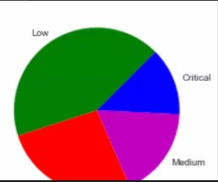

## FIGURE 9.1

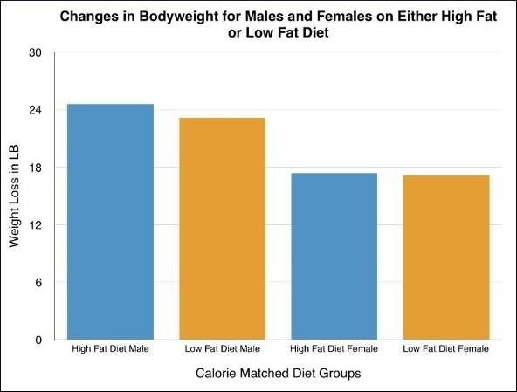

**FIGURE 9.1**

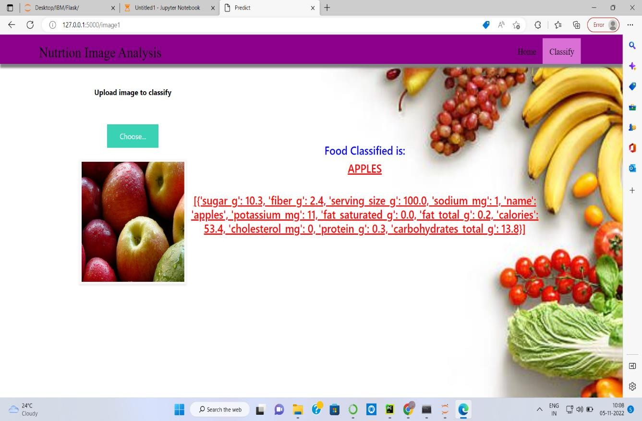

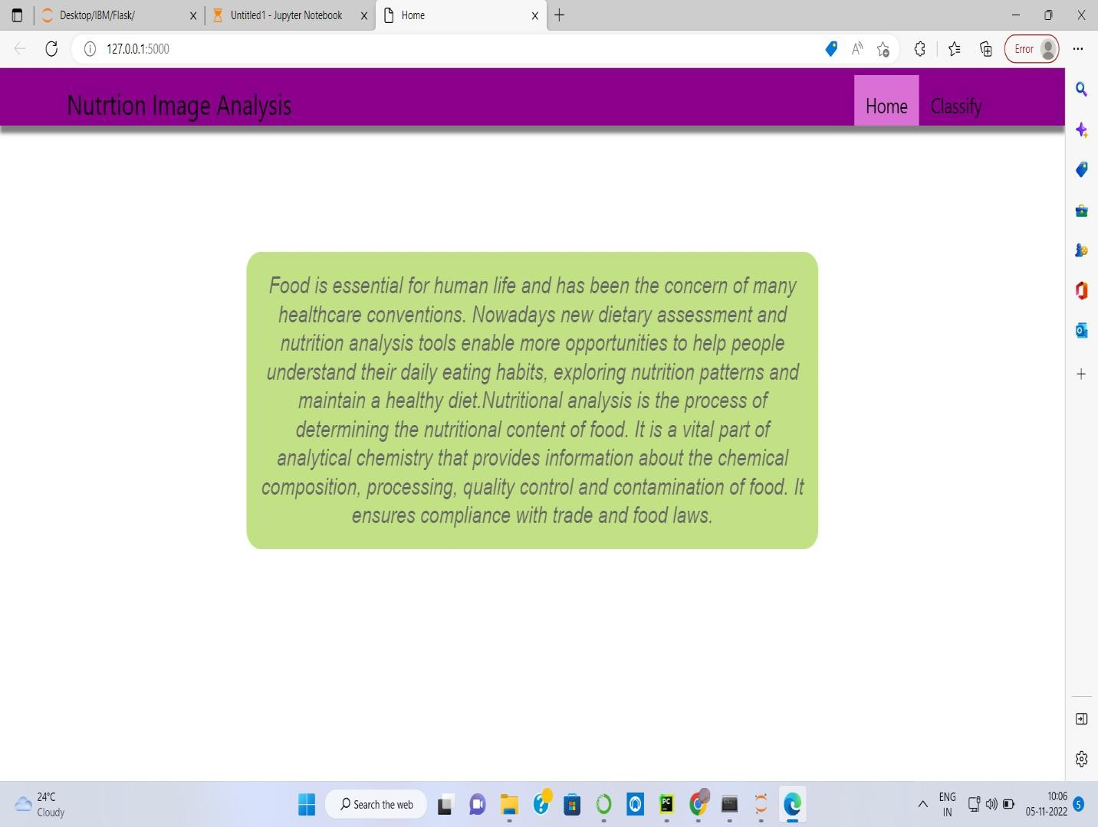

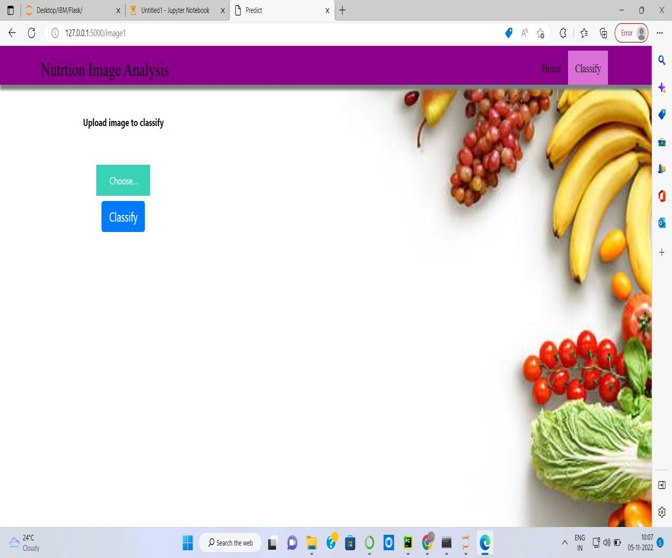

## CHAPTER 10 ADVANTAGES AND DISADVANTAGES

* 1. **ADVANTAGES**
     + These surveys tend to be nationally representative
     + They are often collected every few years and are therefore useful for looking at trends in consumption
     + They are useful for looking at questions surrounding food security and nutrition
     + They include other variables such as socioeconomic status and education
     + It analysis the nutritional level of food items.

## DISADVANTAGES

* + - Food consumed away from the house is often not included
    - These data measure apparent consumption but not actual consumption
    - Does not allow for individual-level measurements, data is on the house-hold level
    - In this system contains the only consumption level of nutritional levels one.

## CHAPTER 11 CONCLUSION

In this thesis, we delve into the food recognition and nutrition analysis problem. In particular, we explore several detection techniques in existing food related datasets, and generate a new dataset on our own. What’s more, we build a automatic system that can get nutrition facts table for an image with food items. To have a better understanding of why we need to have a food recognition and analysis system, we first introduce the background of how obesity affects the society, and elaborate three most common methods to assess our dietary intake. Each of these three approaches have obvious drawback, and it give us the motivation to build an automatic food recognition and dietary assessment system. order to build an food recognition system, object detection technique plays in important role in it. We first introduce three kinds of object detection streams, that is geometry-based approach, color-based approach and region-based approach, to have a brief taste of how object can be detected using computer vision methods. And we also summarize bunch of state-of-the-art food recognition and dietary assessment systems and models.

## CHAPTER 12 FUTURE SCOPE

As future works, there are several ways we can keep exploring in the future. We divide the future into two main directions. The first is exploring the future of object detection algorithm the second is to explore the future of food analysis system. For the object detection

algorithms, an interest and useful direction is to learn or detect objects in new unseen classes, or incrementally learn to distinguish among subclasses after the "main" class has been learned. If the model is capable of learning new classifiers based on existing ones, it will greatly reduce the effort required to learn new object classes. A possible way to accomplish it is to use unsupervised learning methods.AI algorithms may help better understand and predict the complex and non-linear interactions between nutrition-related data and health outcomes, particularly when large amounts of data need to be structured and integrated, such as in metabolomics. The food industry is complicated, and the route to food sector innovation is extensive, from concept development to commercialization.

## CHAPTER 13 APPENDIX

**Python**

Python is commonly used for developing websites and software, task automation, data analysis, and data visualization. Since it's relatively easy to learn, Python has been adopted by many non-programmers such as accountants and scientists, for a variety of everyday tasks, like organizing finances. Python is widely used in scientific and numeric computing: SciPy is a collection of packages for mathematics, science, and engineering. Pandas is a data analysis and modeling library.

**Numpy**

NumPy is a Python library used for working with arrays.It also has functions for working in domain of linear algebra, fourier transform, and matrices.NumPy was created in 2005 by Travis Oliphant. It is an open source project and you can use it freely.NumPy stands for Numerical Python.

## Jupyter

The Jupyter Notebook is an open source web application that you can use to **c**reate and share documents that contain live code, equations, visualizations, and text. Jupyter Notebooks are a spin- off project from the IPython project, which used to have an IPython Notebook project itself. The name, Jupyter, comes from the core supported programming languages that it supports: Julia, Python, and R. Jupyter ships with the IPython kernel, which allows you to write your programs in Python, but there are currently over 100 other kernels that you can also use.

**Tensorflow**

TensorFlow is an end-to-end open source platform for machine learning. TensorFlow is a rich system for managing all aspects of a machine learning system; however, this class focuses on using a particular TensorFlow API to develop and train machine learning models.

## Security

The design addresses some of the vulnerabilities, such as [buffer overflows](http://en.wikipedia.org/wiki/Buffer_overflow), which have been exploited by malicious software. Additionally, .NET provides a common security model for allapplication.

## Portability

While Microsoft has never implemented the full framework on any system except Microsoft Windows, it has engineered the framework to be platform-agnostic and cross- platform implementations are available for other operating systems (see [Silverlight](http://en.wikipedia.org/wiki/Silverlight) and the [Alternative implementations](http://en.wikipedia.org/wiki/.NET_Framework#Alternative_implementations) section below). Microsoft submitted the specifications for the [Common Language Infrastructure](http://en.wikipedia.org/wiki/Common_Language_Infrastructure) (which includes the core class libraries, [Common Type](http://en.wikipedia.org/wiki/Common_Type_System) [System](http://en.wikipedia.org/wiki/Common_Type_System), and the [Common Intermediate Language](http://en.wikipedia.org/wiki/Common_Intermediate_Language)), the [C#](http://en.wikipedia.org/wiki/C_Sharp_%28programming_language%29) language, and the C++/CLI language to both and the [ISO,](http://en.wikipedia.org/wiki/International_Organization_for_Standardization) making them available as official standards. This makesit possible for third parties to create compatible implementations of the framework and its languages on other platforms.

## Design Features

Because computer systems commonly require interaction between newer and older applications, the CNN Framework provides means to access functionality implemented in newer and older programs that execute outside the environment. Access to [COM](http://en.wikipedia.org/wiki/Component_Object_Model) components is provided in the System.Runtime Interop Services and System. Enterprise Services namespaces of the framework; access to other functionality is achieved using the [P/Invoke](http://en.wikipedia.org/wiki/Platform_Invocation_Services) feature.

* 1. **GITHUB & PROJECT DEMO LINK**
     1. **GITHUB LINK:**

https://github.com[IBM-EPBL](https://github.com/IBM-EPBL)/[**IBM-Project-2689-1658481121**](https://github.com/IBM-EPBL/IBM-Project-2689-1658481121)

* + 1. **PROJECT LINK:**

**PROJECT NAME: AI-POWERED NUTRITION ANALYZER FOR FITNESS ENTHUSIASTS**